**Central Gorge Master Gardener**™ **Association**

**Executive Committee Meeting Minutes**

Held in person and via Zoom on Wednesday, April 10, 2024

Next meeting: Wednesday, May 10, 2024, virtual or in person

**Attendees:** Black, Jim; Bosler, Eric; Bosler, Shari; Bradley, Christie; Corl, Mary; Harty, Jen; Hogie, Leanne; Rousseau, Sandi; Wickersham, Megan; Willett, Tracy; Willis, Joanne; Winfield, Bill

**Treasurer’s Report** (Joanne): Joanne sent out the Treasurer’s report. It was approved.

**Secretary’s Report** (Christie): Changes to the March minutes have been incorporated. The minutes were approved.

**Publicity** (Jen for Margo): Margo would like to find someone with video skills to take over for Mike, who has been taking and editing video for the YouTube Channel. Hope is interested in working with podcasts and social media. We need video editing skills, particularly, and no one is sure if she has the editing background.

Jen Munroe has agreed to assist Margo in promotion of MG educational events.

**Plant Sale** (Sandi): We will have native plants for our plant sale. These were donated from the SWCD native plant sale. Several Master Gardeners are interested in taking some of the bare root plants, and the plant sale team will charge the same price as did SWCD for any taken as bare root plants. They will up-pot the ones that will be sold at the plant sale. They need some large pots for bare root plants with particularly large root structures.

**FISH Garden** (Tracy): Things are going well with the FISH garden this year. Jen would like the garden leaders to give her work party dates so she can add them to the calendar.

**Outreach Team** (Jen): Jen needs someone to assist Dennis with his presentation at the library.

Día Mundial del Niño is all set up and ready to go.

Jen met with the horticulture teacher at Hood River Middle School. They have a lot of projects going on. There will be opportunities for Master Gardeners to assist the students. The classes are in the middle of the day.

Jen has been working to get a custom tablecloth to use for community events. This would fit snug on a table and have the CGMGA logo. She will present the details to the executive committee when she has them.

**Plant and Seed Swap** (Mary Corl): There is a Plant and Seed Swap at the Stevenson Library on April 20 from 10-2. If you have anything to donate, give to Mary Corl. We are not supposed to dig up plants, so we cannot have live plants that have been donated on the Master Gardener table.

**White Salmon Library Plant Clinic** (Megan): April 27 there will be a plant clinic at the White Salmon library, at the same time as the St. Joseph’s plant sale next door. There is a laminated sign at the library.

**Hood River Library Plant Clinic** (Christie): Helga and Christie manned the first plant clinic at the Hood River Library. It was a chilly, blustery day, so they could not tell if 9 is too early or not. (The library opens at 10). We will have to see if turnout is better on a warmer day when people are walking around downtown.

They did have people stop by on their way into the library, so there were a handful of contacts. Almost everyone noted how much they appreciate the Master Gardener tended garden.

Helga and Christie took a small, personal canopy and a small table and folding chairs. They did not want to deal with the large canopy, especially in the small area in which they set up.

The canopies may need to be replaced as they are showing some wear. Jen is looking into ordering a smaller canopy that withstands wind well. At the library, the canopy was set against the south wall near the entrance, which offered some wind protection.

Megan needs to consider who is going to outdoor events that require a canopy, as the large ones we have are a little difficult to handle.

**Newsletter** (Shari): Next week is the newsletter deadline. Shari would like to recruit another person with publishing skills .

**Last Class** (Joanne): Joanne ordered the pizzas for tonight’s class.

**Directory** (Joanne): Joanne wanted feedback on the newsletter and presented her draft. There were a few small adjustments.

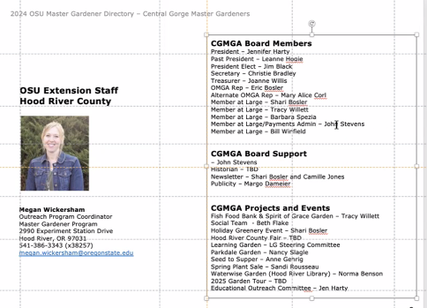

**Nominations** (Jen): The deadline to OMGA for *Master Gardener of the Year* and *Behind the Scenes* is coming up. Megan needs the nominee list by May 1 in order to be presented to OMGA by May 15. There is also a May 15 deadline for OMGA grants, like *Send a Friend* or *Education Coordinator*. Sandi has a list of past winners.

**Board** (Jen): Jen is introducing the executive team to the membership at the class tonight.

**Lavender Farm Visit** (Sandi): Sandi spoke to the owner of the lavender farm, and she would like to offer another garden visit there in July.

**Plant Sale** (Sandi): More aprons need to be ordered. People could wear an apron or a CGMGA t-shirt at the sale. She may order some that are shorter and black. She might add our CGMGA logo to the design.

**T-Shirts** (Jen): There were some extra t-shirts ordered for demo, and Jen will sell them.

**Healing Forest Trip** (Jim Black): The Healing Forest trip will be scheduled June 7. There will be car pools formed. They may ask for donations for the drivers and for the Yakama tribe. We could give them a donation, a bouquet, and a thank you card. The amount of the donation will be discussed at next month’s meeting.

Beth is overseeing social activities. She can work with people on things like hard deadlines for events and sign-ups.

With no further business, the meeting was adjourned at 11:00.

Meeting minutes taken by Christie Bradley